Product Risk Control and Project Risk Control

1-Product Risk Control

🔹 Definition
# Source: AI Source: Provided by: [Data Path: Persons Table -> ID Column: 1, Name_En Column: Motasem Essam] -> From: [Chatgpt (GPT‑5 Mini)] on [8/24/2025]
Product Risk Control is the process of implementing strategies and actions to reduce, mitigate, or eliminate risks related to the product’s quality, functionality, or performance.
It ensures that product risks identified during Product Risk Analysis are properly managed so they don’t negatively impact users, business, or compliance.

🛠️ Key Steps in Product Risk Control

1. Risk Avoidance
# Source: AI Source: Provided by: [Data Path: Persons Table -> ID Column: 1, Name_En Column: Motasem Essam] -> From: [Chatgpt (GPT‑5 Mini)] on [8/24/2025]
- Change the design, architecture, or requirements to avoid the risk entirely.
- Example: Instead of building a complex in-house payment gateway, integrate a well-tested third-party service (Stripe, PayPal).

2. Risk Mitigation
# Source: AI Source: Provided by: [Data Path: Persons Table -> ID Column: 1, Name_En Column: Motasem Essam] -> From: [Chatgpt (GPT‑5 Mini)] on [8/24/2025]
- Reduce the likelihood or impact of the risk by applying preventive measures.
- Example: For the risk of “app crashing under heavy load” → introduce performance testing, caching, and load balancing.

3. Risk Transfer
# Source: AI Source: Provided by: [Data Path: Persons Table -> ID Column: 1, Name_En Column: Motasem Essam] -> From: [Chatgpt (GPT‑5 Mini)] on [8/24/2025]
- Shift the responsibility to another party.
- Example: Outsource security testing to a certified vendor, or buy insurance for financial risks.

4. Risk Acceptance
# Source: AI Source: Provided by: [Data Path: Persons Table -> ID Column: 1, Name_En Column: Motasem Essam] -> From: [Chatgpt (GPT‑5 Mini)] on [8/24/2025]
- Acknowledge the risk but do nothing because its impact is low or cost of mitigation is higher than the benefit.
- Example: Accept minor UI glitches in low-priority areas (like avatar upload) instead of investing heavily to fix them.

5. Testing & Validation (Main Control in QA)
# Source: AI Source: Provided by: [Data Path: Persons Table -> ID Column: 1, Name_En Column: Motasem Essam] -> From: [Chatgpt (GPT‑5 Mini)] on [8/24/2025]
- Design tests to specifically target high-risk areas (risk-based testing).
- Example: If “checkout failure” is high risk → create extra test cases, automated tests, regression tests around checkout flow.

6. Monitoring & Review
# Source: AI Source: Provided by: [Data Path: Persons Table -> ID Column: 1, Name_En Column: Motasem Essam] -> From: [Chatgpt (GPT‑5 Mini)] on [8/24/2025]
- Track risk status during development and testing.
- Update the risk register as risks are controlled, reduced, or new ones appear.

📊 Example – E-commerce Website
# Source: AI Source: Provided by: [Data Path: Persons Table -> ID Column: 1, Name_En Column: Motasem Essam] -> From: [Chatgpt (GPT‑5 Mini)] on [8/24/2025]
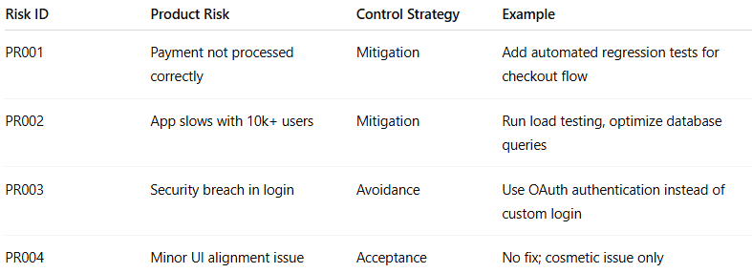
Risk ID | Product Risk | Control Strategy | Example
PR001 | Payment not processed correctly | Mitigation | Add automated regression tests for checkout flow
PR002 | App slows with 10k+ users | Mitigation | Run load testing, optimize database queries
PR003 | Security breach in login | Avoidance | Use OAuth authentication instead of custom login
PR004 | Minor UI alignment issue | Acceptance | No fix; cosmetic issue only

🔹 Why Product Risk Control is Important
# Source: AI Source: Provided by: [Data Path: Persons Table -> ID Column: 1, Name_En Column: Motasem Essam] -> From: [Chatgpt (GPT‑5 Mini)] on [8/24/2025]
✔ Ensures the final product is reliable and safe
✔ Helps prioritize testing effort where failure is most costly
✔ Prevents financial loss, customer dissatisfaction, or legal issues
✔ Supports risk-based decision-making throughout the project

✅ In short:
Product Risk Control = taking actions (avoid, mitigate, transfer, accept) + targeted testing to manage risks that could harm the product’s quality or user experience.

2-Project Risk Control

🔹 Definition
# Source: AI Source: Provided by: [Data Path: Persons Table -> ID Column: 1, Name_En Column: Motasem Essam] -> From: [Chatgpt (GPT‑5 Mini)] on [8/24/2025]
Project Risk Control is the process of taking actions to reduce, monitor, and manage risks that threaten the project’s success (budget, schedule, resources, scope, etc.).
It focuses on managing uncertainties that affect project delivery rather than the product itself.

🛠️ Key Steps in Project Risk Control

1. Risk Avoidance
# Source: AI Source: Provided by: [Data Path: Persons Table -> ID Column: 1, Name_En Column: Motasem Essam] -> From: [Chatgpt (GPT‑5 Mini)] on [8/24/2025]
- Change the project plan to eliminate risks.
- Example: If “tight deadline” is a risk → negotiate more time with stakeholders.

2. Risk Mitigation
# Source: AI Source: Provided by: [Data Path: Persons Table -> ID Column: 1, Name_En Column: Motasem Essam] -> From: [Chatgpt (GPT‑5 Mini)] on [8/24/2025]
- Reduce the likelihood or impact of risks.
- Example: If “team lacks expertise” → arrange training or hire experts.

3. Risk Transfer
# Source: AI Source: Provided by: [Data Path: Persons Table -> ID Column: 1, Name_En Column: Motasem Essam] -> From: [Chatgpt (GPT‑5 Mini)] on [8/24/2025]
- Shift responsibility to a third party.
- Example: Outsource part of development or use a vendor for specialized tasks.

4. Risk Acceptance
# Source: AI Source: Provided by: [Data Path: Persons Table -> ID Column: 1, Name_En Column: Motasem Essam] -> From: [Chatgpt (GPT‑5 Mini)] on [8/24/2025]
- Accept risks when cost of mitigation is too high or impact is low.
- Example: Accept risk of a minor documentation delay that doesn’t affect delivery.

5. Monitoring & Review
# Source: AI Source: Provided by: [Data Path: Persons Table -> ID Column: 1, Name_En Column: Motasem Essam] -> From: [Chatgpt (GPT‑5 Mini)] on [8/24/2025]
- Continuously track risk status in the risk register.
- Update risk response plans when changes happen (e.g., new dependencies, delays).

📊 Example – Project Risk Control (E-commerce Project)
# Source: AI Source: Provided by: [Data Path: Persons Table -> ID Column: 1, Name_En Column: Motasem Essam] -> From: [Chatgpt (GPT‑5 Mini)] on [8/24/2025]
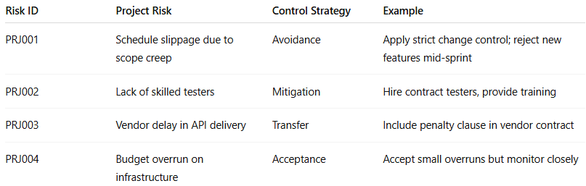
Risk ID | Project Risk | Control Strategy | Example
PRJ001 | Schedule slippage due to scope creep | Avoidance | Apply strict change control; reject new features mid-sprint
PRJ002 | Lack of skilled testers | Mitigation | Hire contract testers, provide training
PRJ003 | Vendor delay in API delivery | Transfer | Include penalty clause in vendor contract
PRJ004 | Budget overrun on infrastructure | Acceptance | Accept small overruns but monitor closely

🔹 Project Risk Control vs Product Risk Control
# Source: AI Source: Provided by: [Data Path: Persons Table -> ID Column: 1, Name_En Column: Motasem Essam] -> From: [Chatgpt (GPT‑5 Mini)] on [8/24/2025]
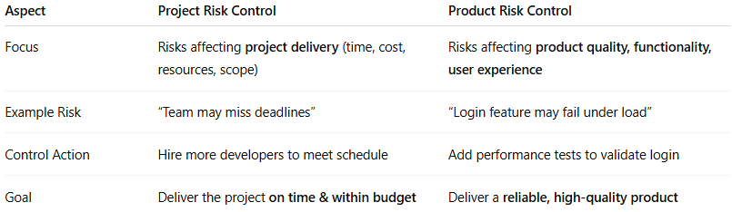
Aspect | Project Risk Control | Product Risk Control
Focus | Risks affecting project delivery (time, cost, resources, scope) | Risks affecting product quality, functionality, user experience
Example Risk | “Team may miss deadlines” | “Login feature may fail under load”
Control Action | Hire more developers to meet schedule | Add performance tests to validate login
Goal | Deliver the project on time & within budget | Deliver a reliable, high-quality product

✅ In short:
Project Risk Control = Actions to manage risks that may delay or derail the project’s execution (resources, schedule, budget).
Product Risk Control = Actions to manage risks that may reduce the quality or usability of the delivered system.

